Contact: Ali Harp FOR IMMEDIATE RELEASE
Phone: 706-712-0953
Email: harp@daltonchamber.org

Dalton-Whitfield Joint Development Authority Honors Skeeter Pierce
(Dalton, GA- January 26, 2020) On Tuesday January 19, the Dalton-Whitfield County Joint Development Authority (DWJDA) honored a leader of the DWJDA Board, and a valued member of the Dalton community.
Sara “Skeeter” Pierce was presented with a service award to commemorate her years serving on the Dalton Whitfield County Joint Development Authority Board of Directors. Mrs. Pierce joined the board in 2015.
During her tenure on the board, the DWJDA was able to announce over 1,300 jobs and $850 million in capital investment to be created through projects in Dalton.
“We are grateful to Mrs. Pierce for her years of service to the Dalton-Whitfield JDA Board. She is an optimistic person who was always ready and willing to help with JDA efforts. Skeeter works hard to run her own business, so we appreciate her willingness to share her guidance, wisdom, and friendship. She will be missed by this board.” said Carl Campbell, Executive Director of the DWJDA.
We thank Mrs. Pierce for her dedication, service, and leadership.
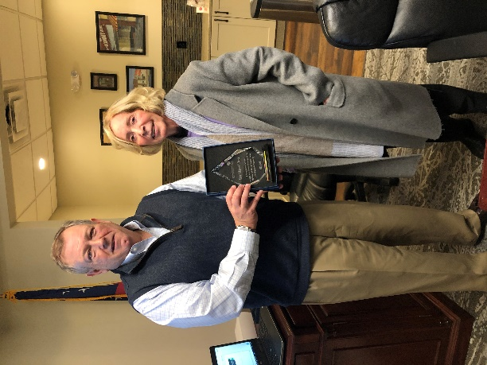
Kevin Harris, Chairman and Skeeter Pierce
About Dalton-Whitfield County Joint Development Authority
The Dalton-Whitfield County Joint Development Authority provides a full range of economic development services to both existing and prospective businesses in Greater Dalton. As the general development agency for Dalton and Whitfield County, the Authority is a public-private partnership whose primary goal is to promote economic growth and stability by supporting existing businesses, targeting new businesses, and attracting new investment into the community.
Visit www.locationdalton.com to learn more about the Dalton-Whitfield County Joint Development Authority.
###

